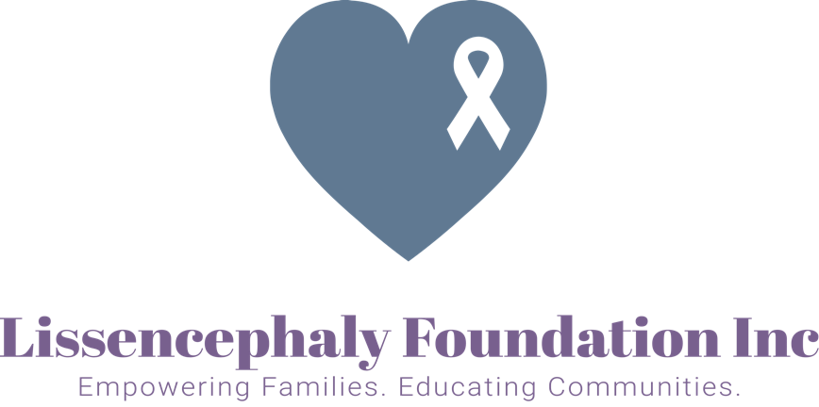

Lissencephaly Awareness Day Proclamation

WHEREAS Lissencephaly is a rare gene-linked brain malformation, causing the brain to have less or no ridges & folds; making it appear smooth. It is estimated about 1 in 100,000 individuals are born with this condition

WHEREAS people living with this condition may also suffer from hypertonia, epilepsy, swallowing disorders, developmental delays, and more

WHEREAS addressing the complex medical needs early in life is imperative to helping families successfully care for their children at home. The need for more education, awareness & support for families is desperately needed

WHEREAS It is appropriate that one day each year should be set apart from the rest and be known as Lissencephaly Awareness Day, this day shall be on September 8th

WHEREAS Lissencephaly Foundation Inc; a nonprofit charitable organization wants to help support these individuals through our continued efforts of empowering families and educating communities;

NOW, THEREFORE, I _____________________________________, do hereby proclaim September 8th, to be known in __________________________ as

Lissencephaly Awareness day

AND urge our citizens, patients, caregivers, medical professionals and all agencies and organizations interested in supporting these families to unite on that day in observance of such exercises.

